**1. Fetch user account details**

o Endpoint: GET /services/bank/customers/{customerId}/accounts

o Validate response status code = 200.

o Ensure the response contains a list of valid accounts.



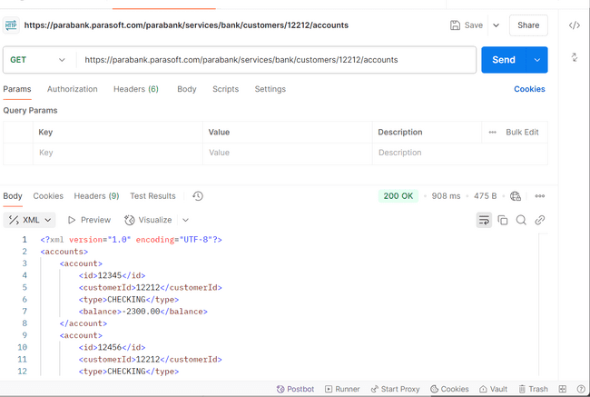

<?xml version="1.0" encoding="UTF-8"?><accounts><account><id>12345</id><customerId>12212</customerId><type>CHECKING</type><balance>-2300.00</balance></account><account><id>12456</id><customerId>12212</customerId><type>CHECKING</type><balance>10.45</balance></account><account><id>12567</id><customerId>12212</customerId><type>CHECKING</type><balance>100.00</balance></account><account><id>12678</id><customerId>12212</customerId><type>SAVINGS</type><balance>-100.00</balance></account><account><id>12789</id><customerId>12212</customerId><type>CHECKING</type><balance>100.00</balance></account><account><id>12900</id><customerId>12212</customerId><type>CHECKING</type><balance>0.00</balance></account><account><id>13011</id><customerId>12212</customerId><type>CHECKING</type><balance>100.00</balance></account><account><id>13122</id><customerId>12212</customerId><type>CHECKING</type><balance>1100.00</balance></account><account><id>13233</id><customerId>12212</customerId><type>CHECKING</type><balance>100.00</balance></account><account><id>13344</id><customerId>12212</customerId><type>SAVINGS</type><balance>1231.10</balance></account><account><id>54321</id><customerId>12212</customerId><type>CHECKING</type><balance>1351.12</balance></account></accounts>

**2. Fetch Customer Account Info**

a. Endpoint: GET /services/bank/customers/{customerId}/accounts

b. Task: Retrieve all accounts for a user.

c. Validation: Check the account list is not empty, validate schema/keys.



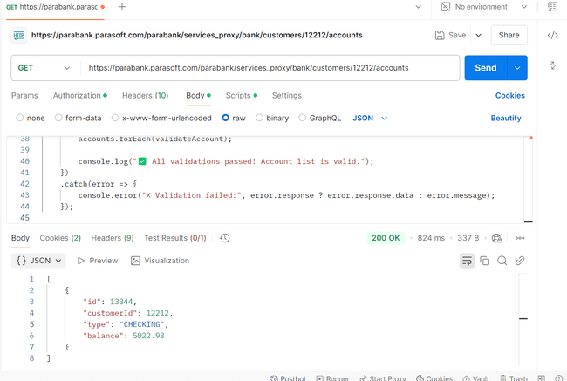

[{"id":13344,"customerId":12212,"type":"CHECKING","balance":5022.93}]

**3. Perform a fund transfer via API**



Endpoint: POST /services/bank/transfer

o Pass the from AccountId, toAccountId, and amount as JSON payload.

o Validate the transaction is successfully recorded.

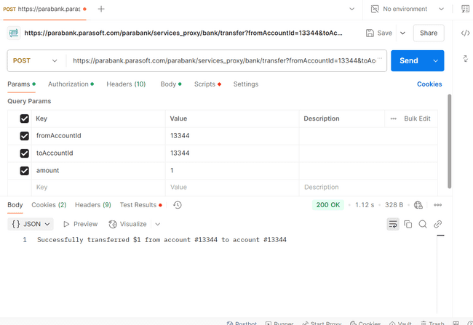

**Response:** Successfully transferred $1 from account #13344 to account #13344

**4. Validate transaction history via API**



o Endpoint: GET /services/bank/accounts/{accountId}/transactions

o Ensure the latest transaction appears in the list.

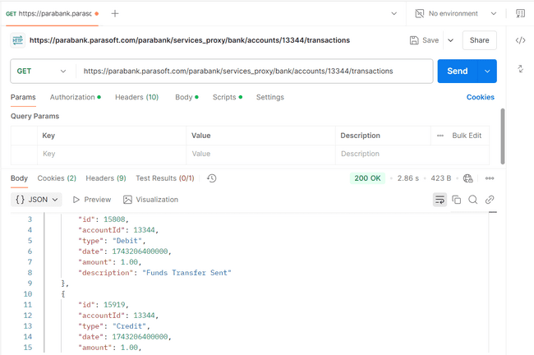

**Response:**

[{"id":15808,"accountId":13344,"type":"Debit","date":1743206400000,"amount":1.00,"description":"Funds Transfer Sent"},{"id":15919,"accountId":13344,"type":"Credit","date":1743206400000,"amount":1.00,"description":"Funds Transfer Received"},{"id":16030,"accountId":13344,"type":"Debit","date":1743206400000,"amount":1.00,"description":"Funds Transfer Sent"},{"id":16141,"accountId":13344,"type":"Credit","date":1743206400000,"amount":1.00,"description":"Funds Transfer Received"},{"id":18250,"accountId":13344,"type":"Debit","date":1743206400000,"amount":1.00,"description":"Funds Transfer Sent"},{"id":18361,"accountId":13344,"type":"Credit","date":1743206400000,"amount":1.00,"description":"Funds Transfer Received"}]

**Open a New Account**

**a. Endpoint: POST /services/bank/accounts**

**b. Task: Open a new checking/savings account.**

**c. Validation: Validate response includes account ID.**



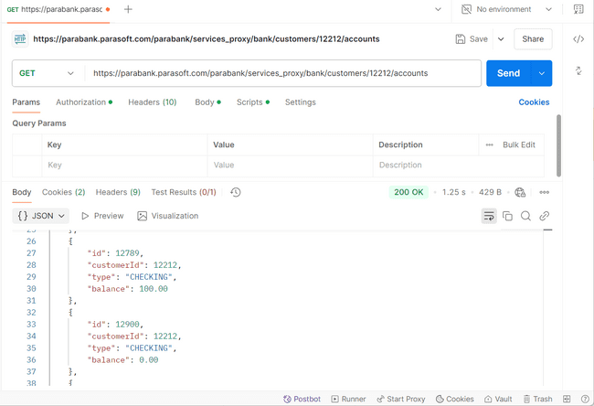

**Response:**[{"id":12345,"customerId":12212,"type":"CHECKING","balance":-2400.00},{"id":12456,"customerId":12212,"type":"CHECKING","balance":10.45},{"id":12567,"customerId":12212,"type":"CHECKING","balance":100.00},{"id":12678,"customerId":12212,"type":"SAVINGS","balance":-100.00},{"id":12789,"customerId":12212,"type":"CHECKING","balance":100.00},{"id":12900,"customerId":12212,"type":"CHECKING","balance":0.00},{"id":13011,"customerId":12212,"type":"CHECKING","balance":100.00},{"id":13122,"customerId":12212,"type":"CHECKING","balance":1100.00},{"id":13233,"customerId":12212,"type":"CHECKING","balance":100.00},{"id":13344,"customerId":12212,"type":"SAVINGS","balance":1231.10},{"id":14898,"customerId":12212,"type":"CHECKING","balance":100.00},{"id":54321,"customerId":12212,"type":"CHECKING","balance":1351.12}]

Update Profile API:

